December update (preschool):

Monthly Topic: Christmas and celebrations
How can you help at home?
- Talk to your child about the Nativity Story. Can they tell you what happened? Sing the songs with them at home and talk about dressing up/putting on a show
- We are focusing on scissor skills in school this month: please give your child opportunities to practice at home
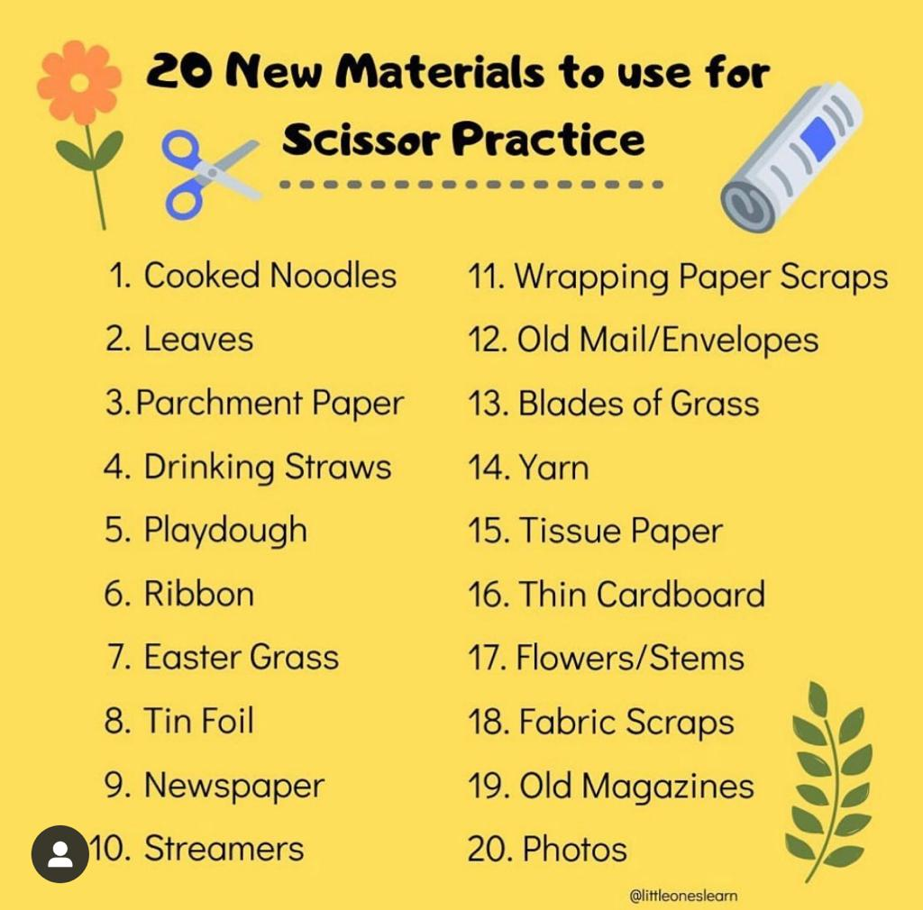

- Increase your child’s awareness of patterns: talk about patterns on wrapping paper, scarves, decorations, lights etc.

Christmas Nativity Play:
FT class: Wednesday (6th) at 10.30am. Parents bring children to school for 10am and then walk around to the front door of school for tea/coffee and mince pies. All children will go home with a grown up after the show. NO SCHOOL FOR Am CLASS ON THIS DAY
PM class: Wednesday (6th) at 1pm. Parents bring children to school for 12.30pm and then walk around to the front door of school for tea/coffee and mince pies. All children will go home with a grown up after the show.
AM class: Thursday (7th)at 10.30am. Parents bring children to school for 10am and then walk around to the front door for tea/coffee and mince pies. All children will go home with a grown up after the show. NO SCHOOL FOR FT CLASS ON THIS DAY.

At the moment, we have children off school with various bugs and seasonal illnesses. If your child is unwell, we ask that you do not send them into school. We appreciate that it is a great disappointment for parents if their child is unable to take part in the show, HOWEVER, it is not the same disappointment for your child. At this age, children have very little understanding of what it is to perform in a show and in fact, for many, this is something they will find extremely daunting. The achievement for each child is that they have learnt the songs and have a great understanding of why we celebrate Christmas. You will have many years to come watching your child perform in school plays etc and we ask at this time that you are mindful of spreading illnesses to both children and staff in the run up to Christmas.

Reminder: donations will be taken on both Nativity Play days towards Action for Children. Donation boxes will be available in the snack room.

Christmas Jumper Day: Friday 15th December

Model PS Christmas show:
Children in both AM and FT class will be walking across to the Model PS on Friday 8th to watch their school show and have snack in the school. We will be leaving shortly after 9am so please ensure that your child is in school on time and that they are wearing a suitable coat etc.

Christmas Dinner (FT class): Our class Christmas dinner will be served on Thursday 14th

Big Bedtime Read Night;
Thursday 14th 6.30-7.30pm: children can come to school in their PJ’s for some supper and a treat. Children must be accompanied by an adult and staff are not responsible for children on this night. Book bags can be returned on this night or to school the next day

Christmas party:
Thursday 21st: children can come dressed in party clothes. The magician will be in school. School will finish for all children at 11.30 am on this day.

Finally, can I take the opportunity on behalf of all the staff to wish you a happy, healthy and peace filled Christmas time. The greatest present you can give your child this year is your presence! Enjoy time with them, snuggle up with them and talk to them. Children will not remember what was under the Christmas tree this year when they look back, but they will remember the memories of time spent together with the people they love.
We look forward to working together with you in 2024
Mrs Phair and all the staff of Enniskillen Nursery School.

