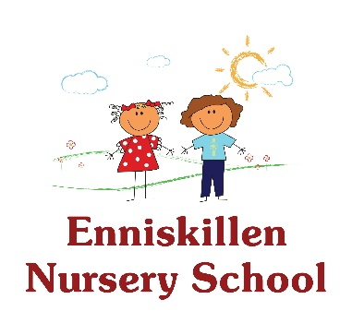

Is your child due to start Pre-School in September 2024?

Come along to our Peek and Play afternoons

Meet our staff and see what our Nursery School has to offer

your child in their Pre-School year.

Friday 1st December 2023 & Friday 8th December 2023

2.15-3.00pm

Saturday 6th January 2024 : 10am – 11am

Email: [eknns@btinternet.com](mailto:eknns@btinternet.com) to register interest